Versaic – Navy Federal User Guide
Submitting a grant application:
- To access the Navy Federal Submitter Portal copy and paste the following URL into your web browser: https://navyfederal.versaic.com/
- Enter your username and password and then click ‘Log in’ or to create an account click ‘Create Account’.
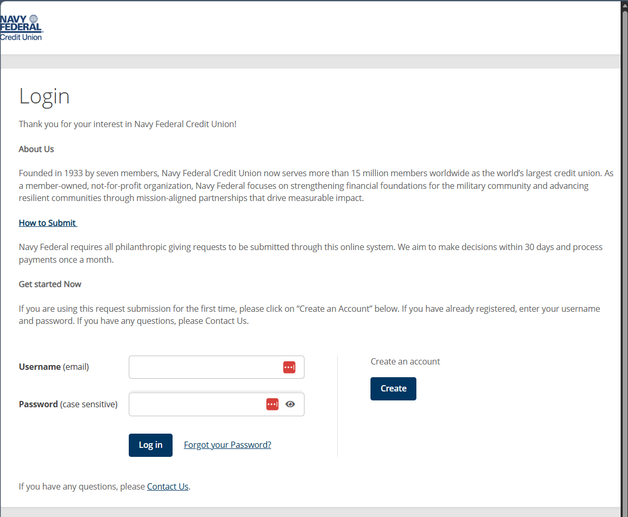
- To create a proposal, click ‘Get Started’.
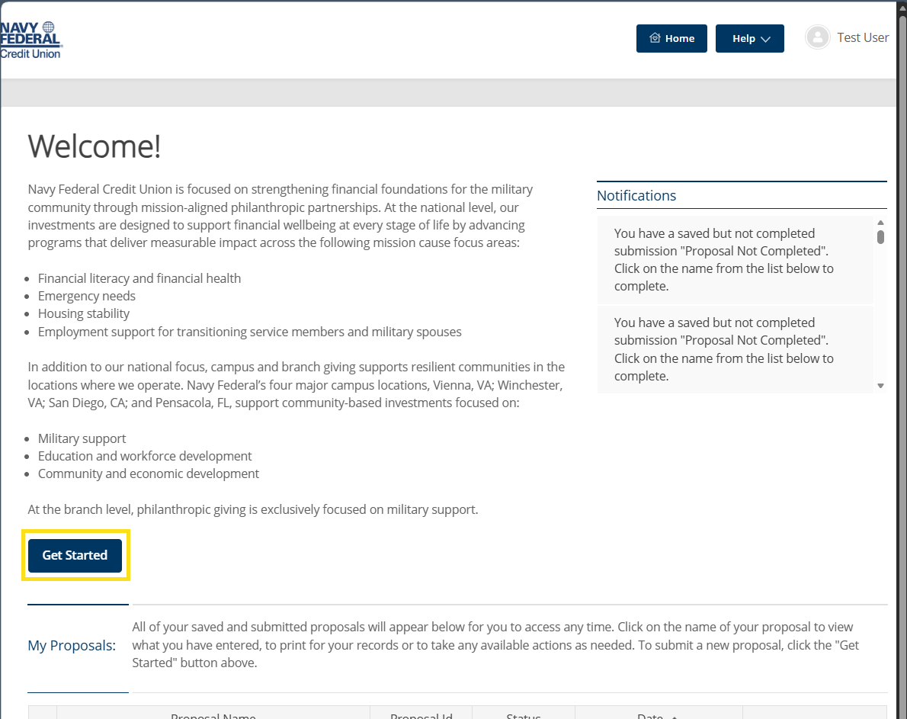
- Review and answer the questions on each page. Questions with a red * are required.
- Click ‘Submit’ once you’ve completed answering the required questions.
- A confirmation message will appear asking if you are ready to submit.
- Click ‘Submit’.
- You should successfully arrive at the “Thank you for your submission” confirmation page for each application stream you go through.
- Click ‘Finish’ to go back to the ‘Home’ page.

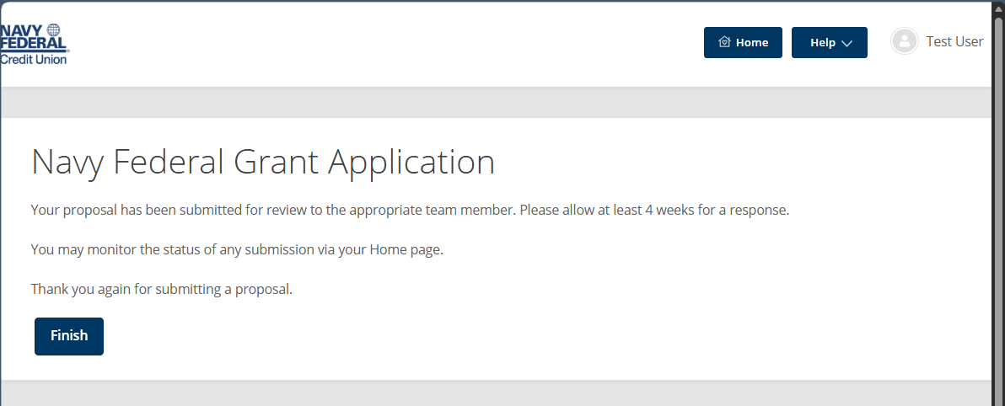

Submitting an Impact Survey:
After your program has concluded, you may be required to submit an Impact Survey. This survey helps us understand program activities, outcomes, and the impact of Navy Federal’s support, and is used for internal reporting, learning, and storytelling.
- To navigate to the Impact Survey, click on the link provided in the email sent to you from [email].
- You will be brough to the Impact Survey to fill out your funded program’s outcomes.
- Fill out the survey questions and review your answers. Then click “Submit” at the bottom of the screen. If you need to save your answers and return to the survey, click “Save & Close” at the bottom of the screen.

Additional Features:
Requesting Help – The Versaic platform Zendesk for Applicant Support.
- Click the ‘Help’ button, then click ‘Request Help’.
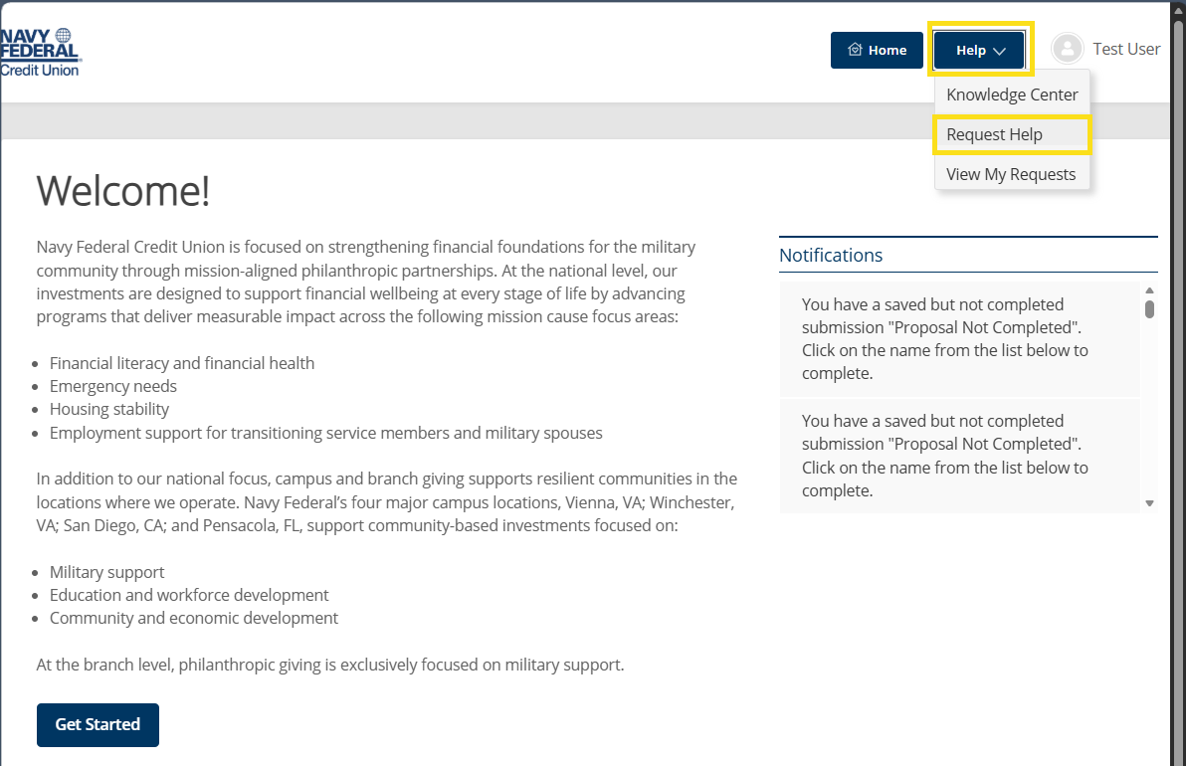
- Select the most applicable category related to your question, then click ‘Next’.
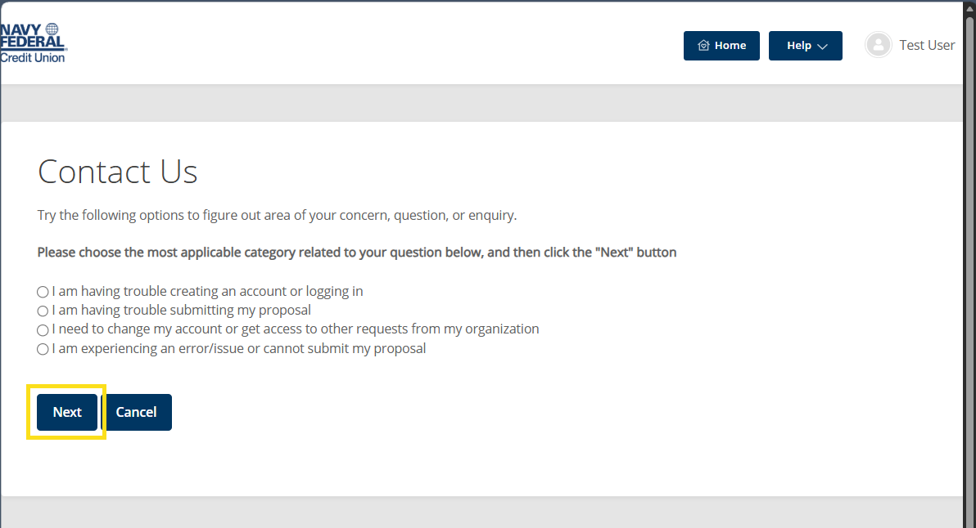
- Depending on the issue you are encountering, try the following options to figure out the area of concern. For example:
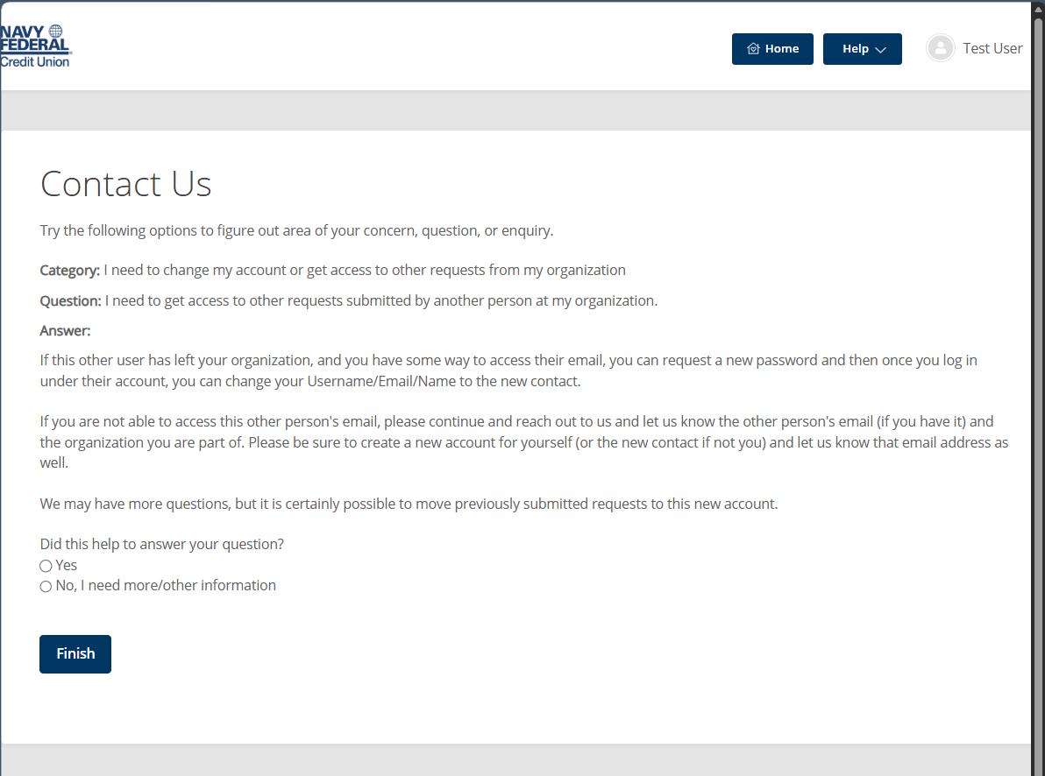
- If your question was not answered, and you selected ‘No, I need more/other information’, you will be redirected to create a ticket to be reviewed by a member of the Benevity team.
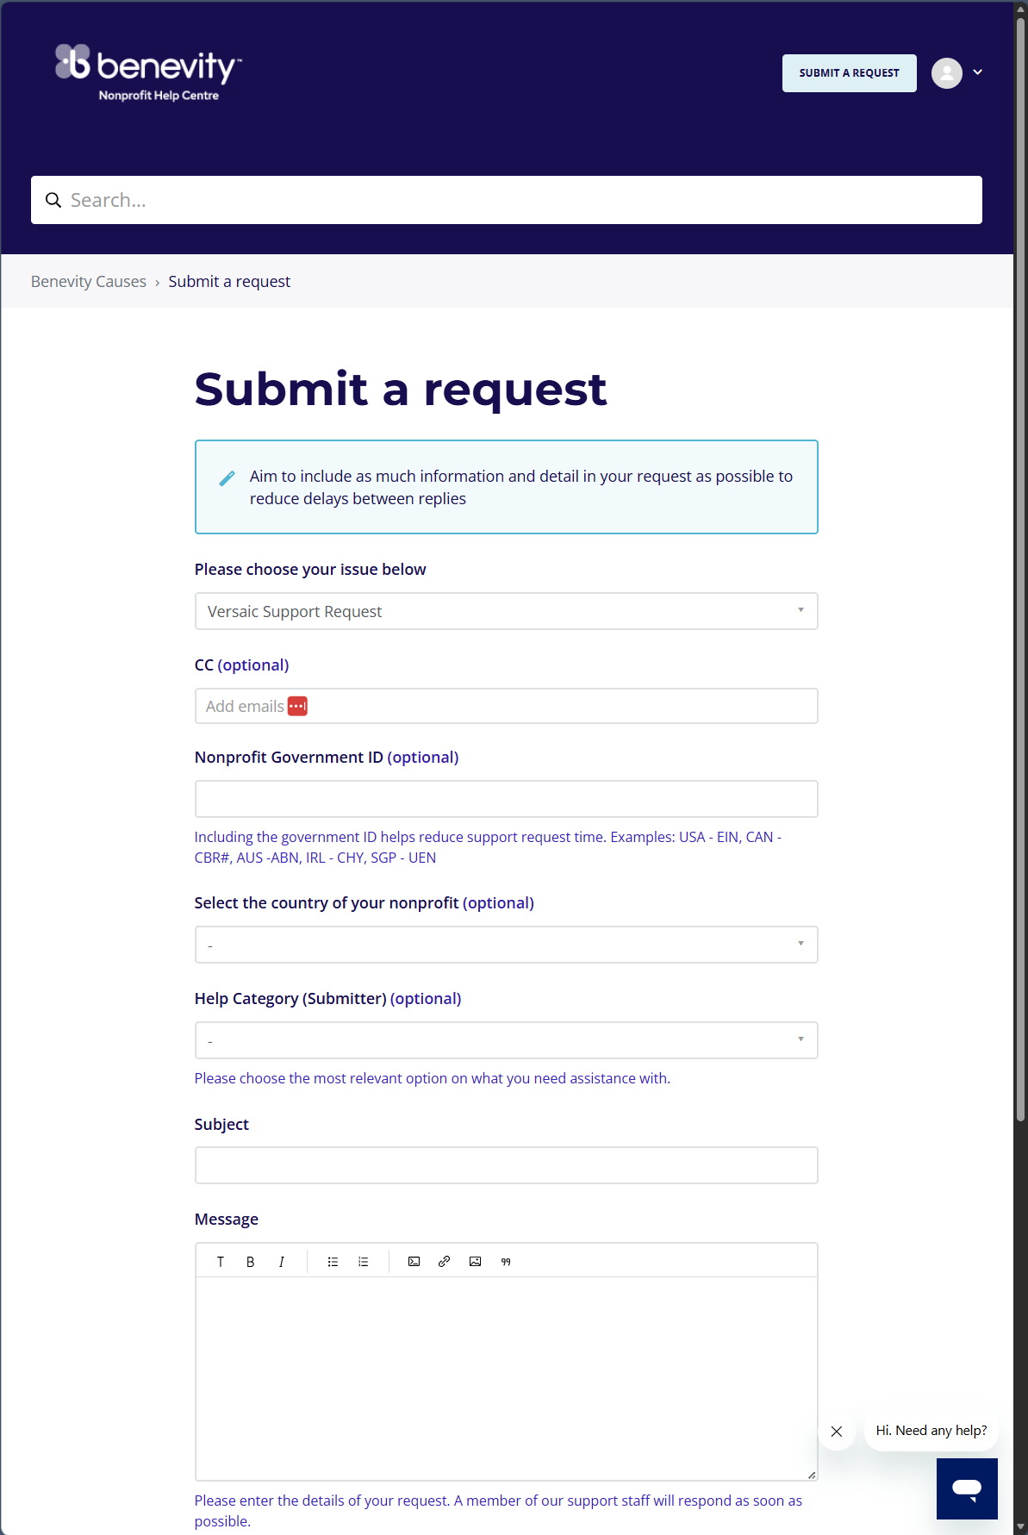
Fill the ticket form out completely and click ‘Submit’ at the bottom of the screen.
Viewing your Submitted Requests
- Click ‘View My Requests’ to view submitted requests.
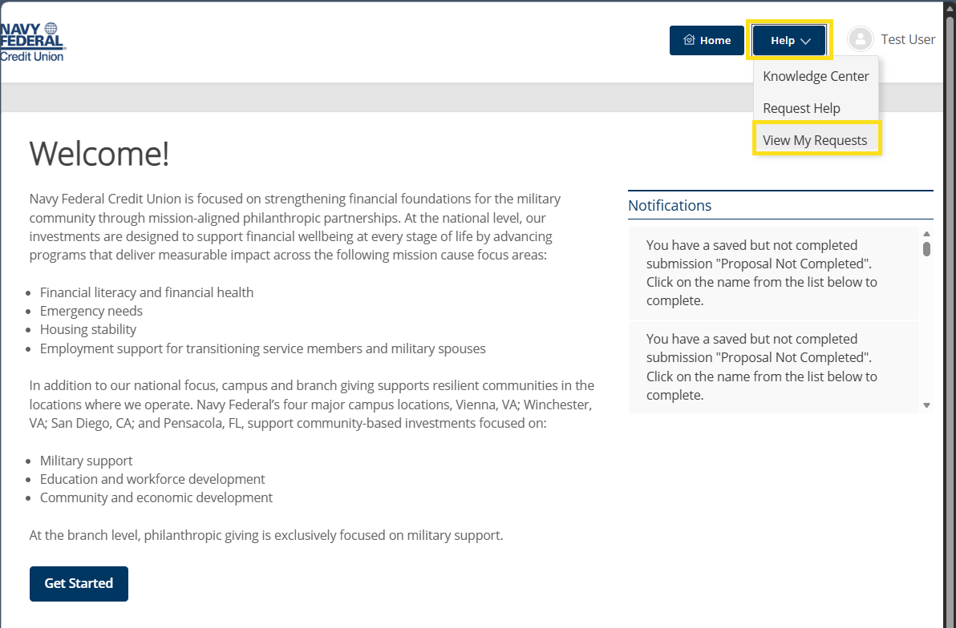
- If you have any requests open, they will be listed.
Profile Update – The Versaic platform allows applicants to update their own profiles:
- From the Home Page, in the upper right-hand side, click your Name and then ‘My Account’.
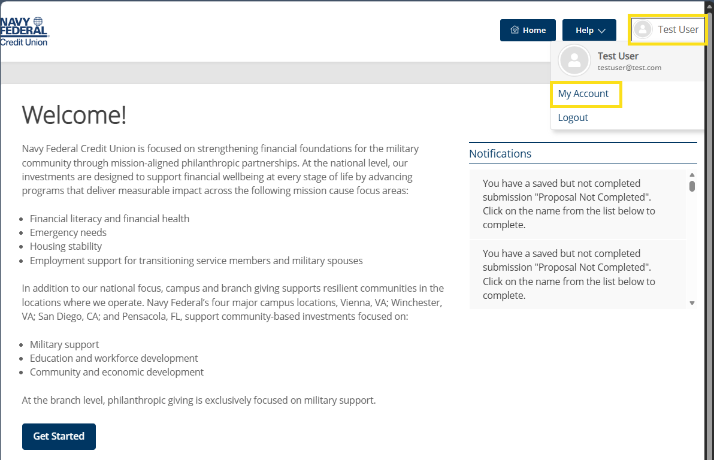
- To update/change your Username click ‘Change Username’, to update/change your Password click ‘Change Password’.
